E-Commerce Website – Report (First Submission)

Angelika Stachura

Ammar Jalo

Riyam Alsharifi

**Date of submission:**

**Tutor**: Dr David Gamez

**CSD2550**

**WEB APPLICATIONS AND DATABASES**

**WEBSITE**

The purpose of this report is to illustrate features of the website and database we have created along with the progress that was made so far and team members contribution to the project.

The colour scheme chosen for the website consist of mainly green, black and white. Logo was created to compliment the colour scheme.

The group project assigned to us is an e-commerce website and as a unit we decided to work on a game selling website, the products we offer can be found in the All Games, Xbox and PlayStation sections of the website along with price tags and option to add it to the shopping cart.

Main features of the website:

* Drop down menu - this feature compliments the minimalistic design of the website, make the page appear well-designed and simple, it also makes the website more efficient especially if there are many pages,
* Search bar - the search bar is a feature that allows the user to narrow searches down to specific items or categories of a website as an example a customer can use the search bar to find certain games easier. Search bar has been implemented using CSS transitions which adds animation for better user experience,
* Add to cart - the add to the cart function stores the customer’s choices of games in the basket, this data is store until the customer close the browser.

Home page features simple slideshow introducing products our shop is offering. Slideshow was implemented using HTML, CSS and JavaScript. Icons we have used are a Google Icons library.

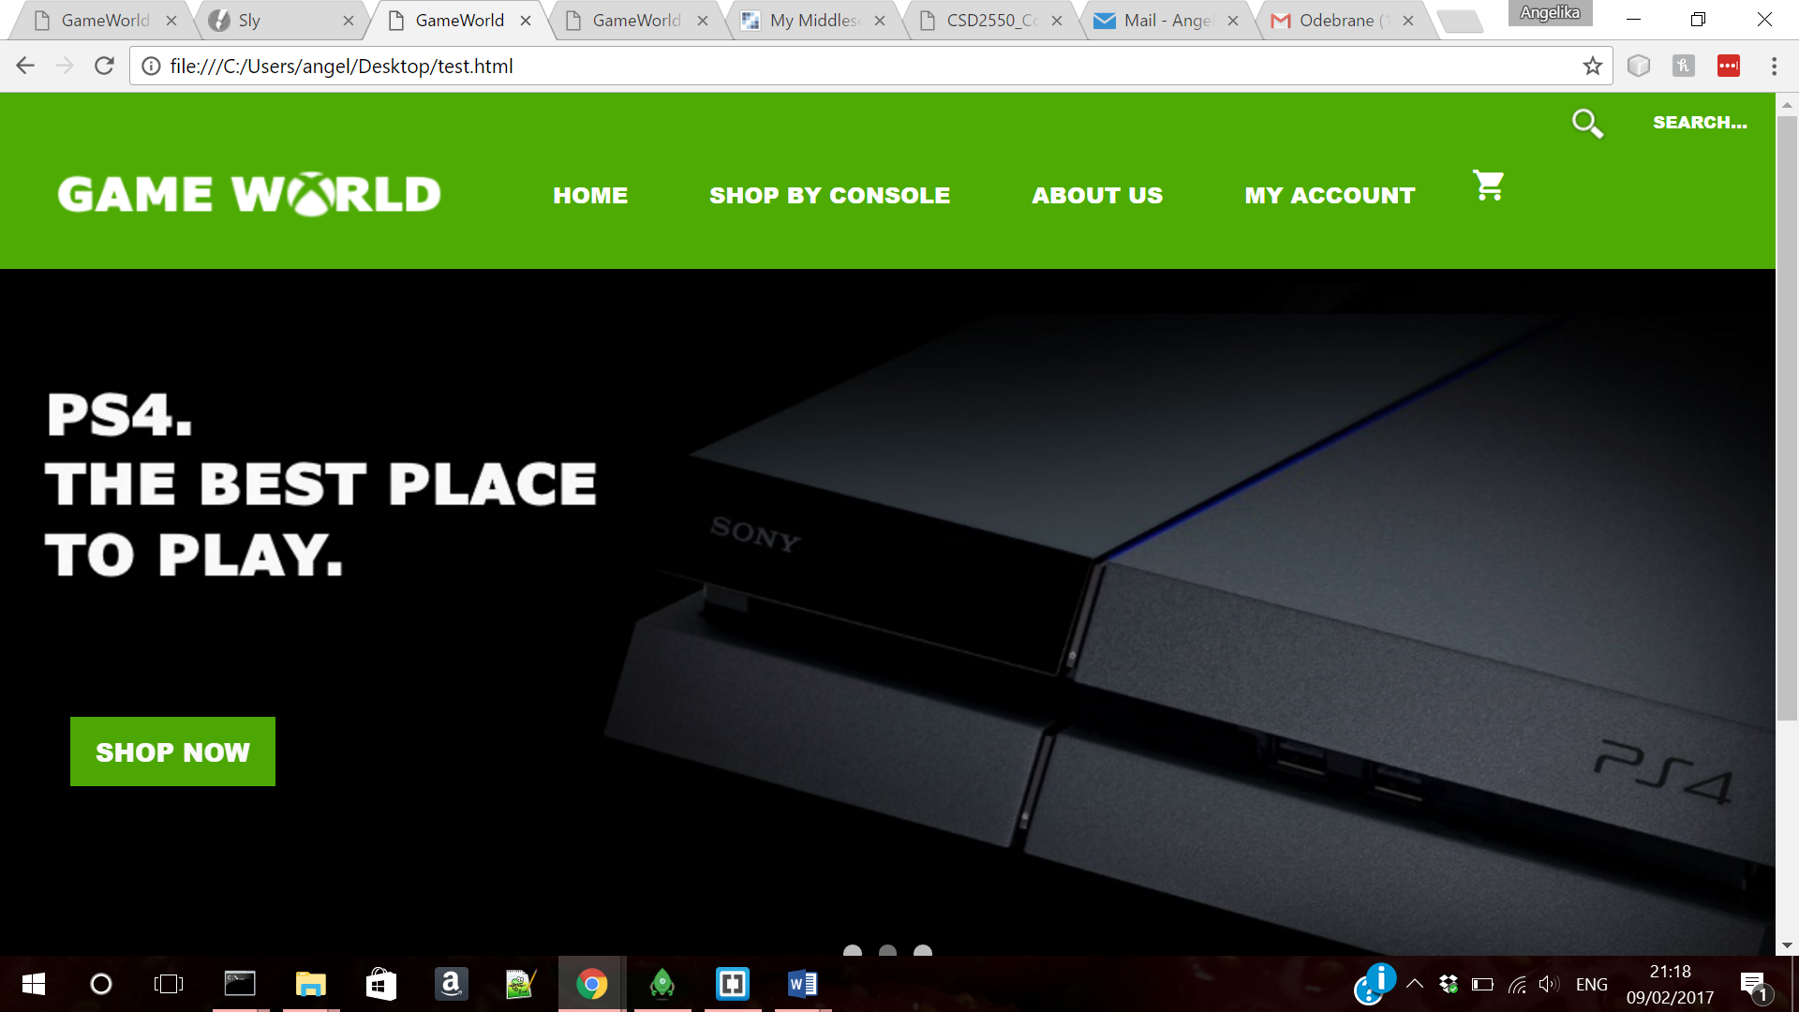

Products page contains extra side navigation allows customer to shop by genre. Customers also can shop by console: Xbox or PlayStation.

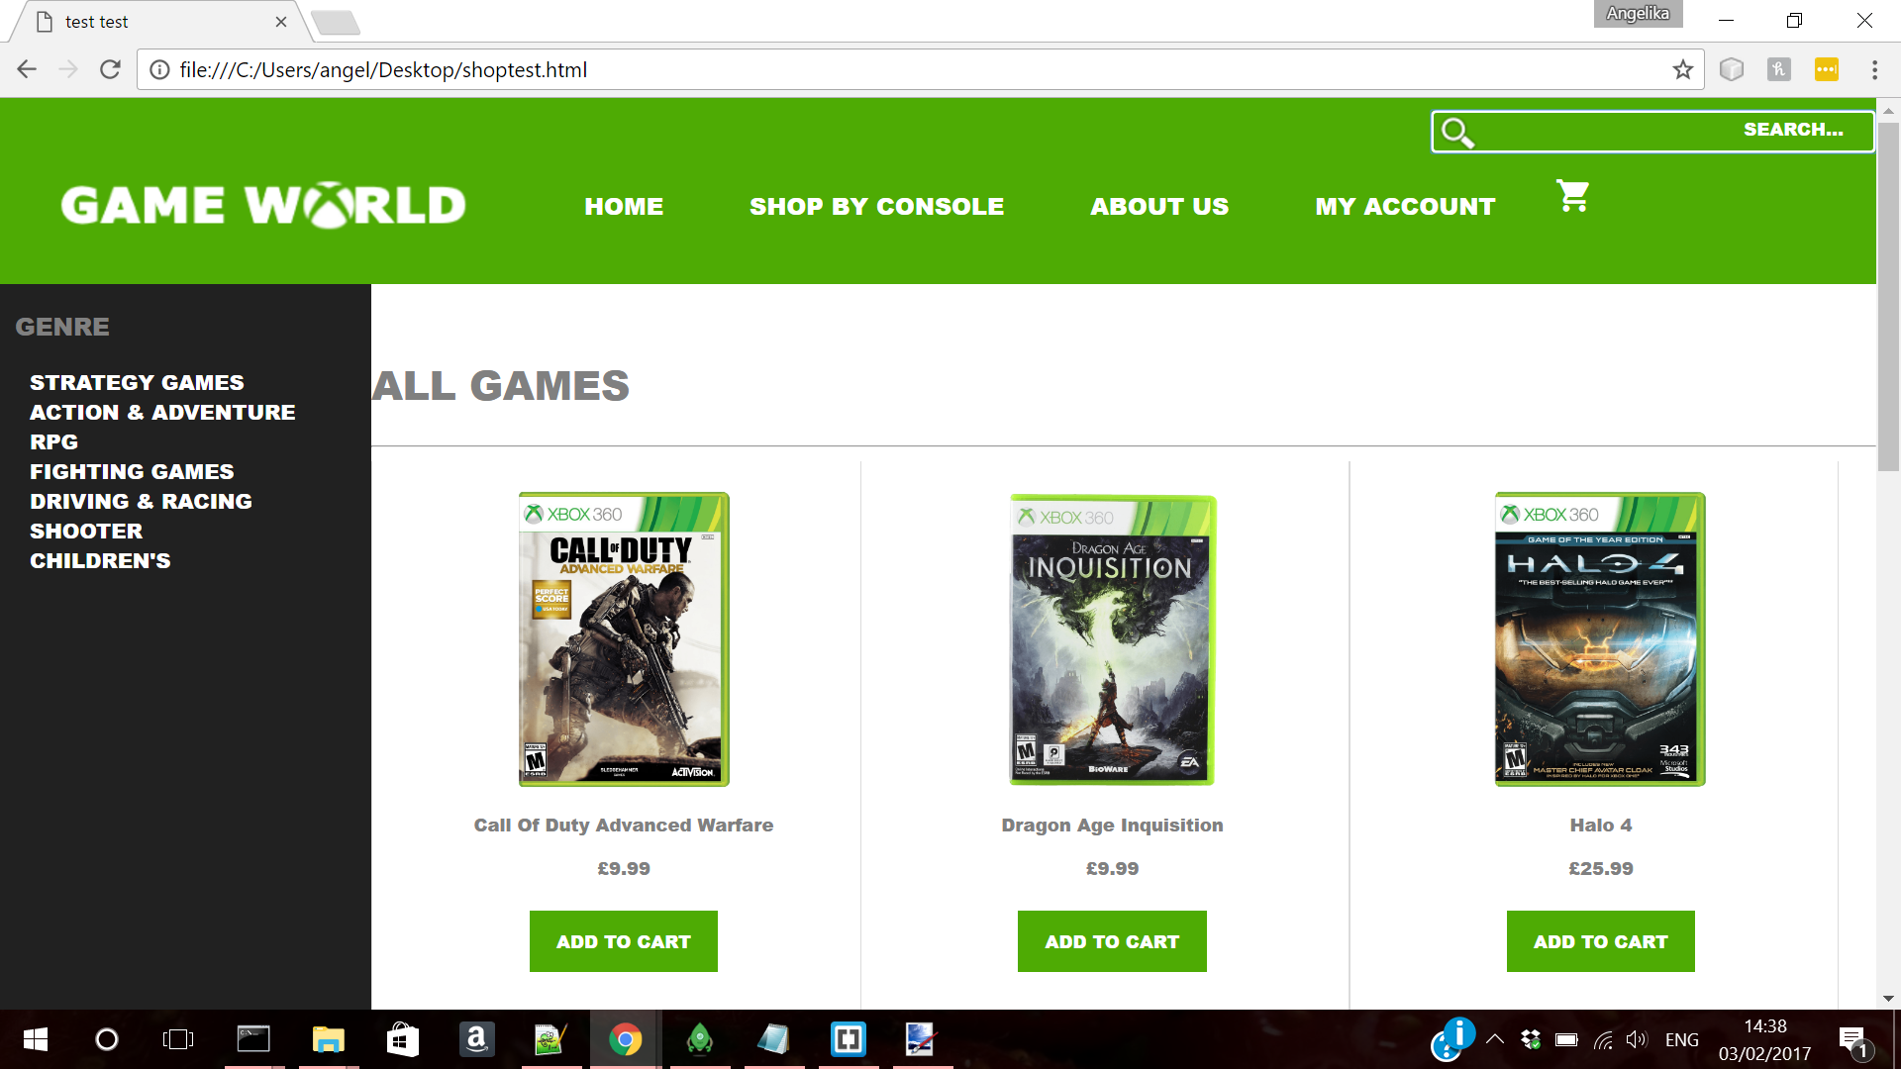

About us page gives customer information regarding the company.

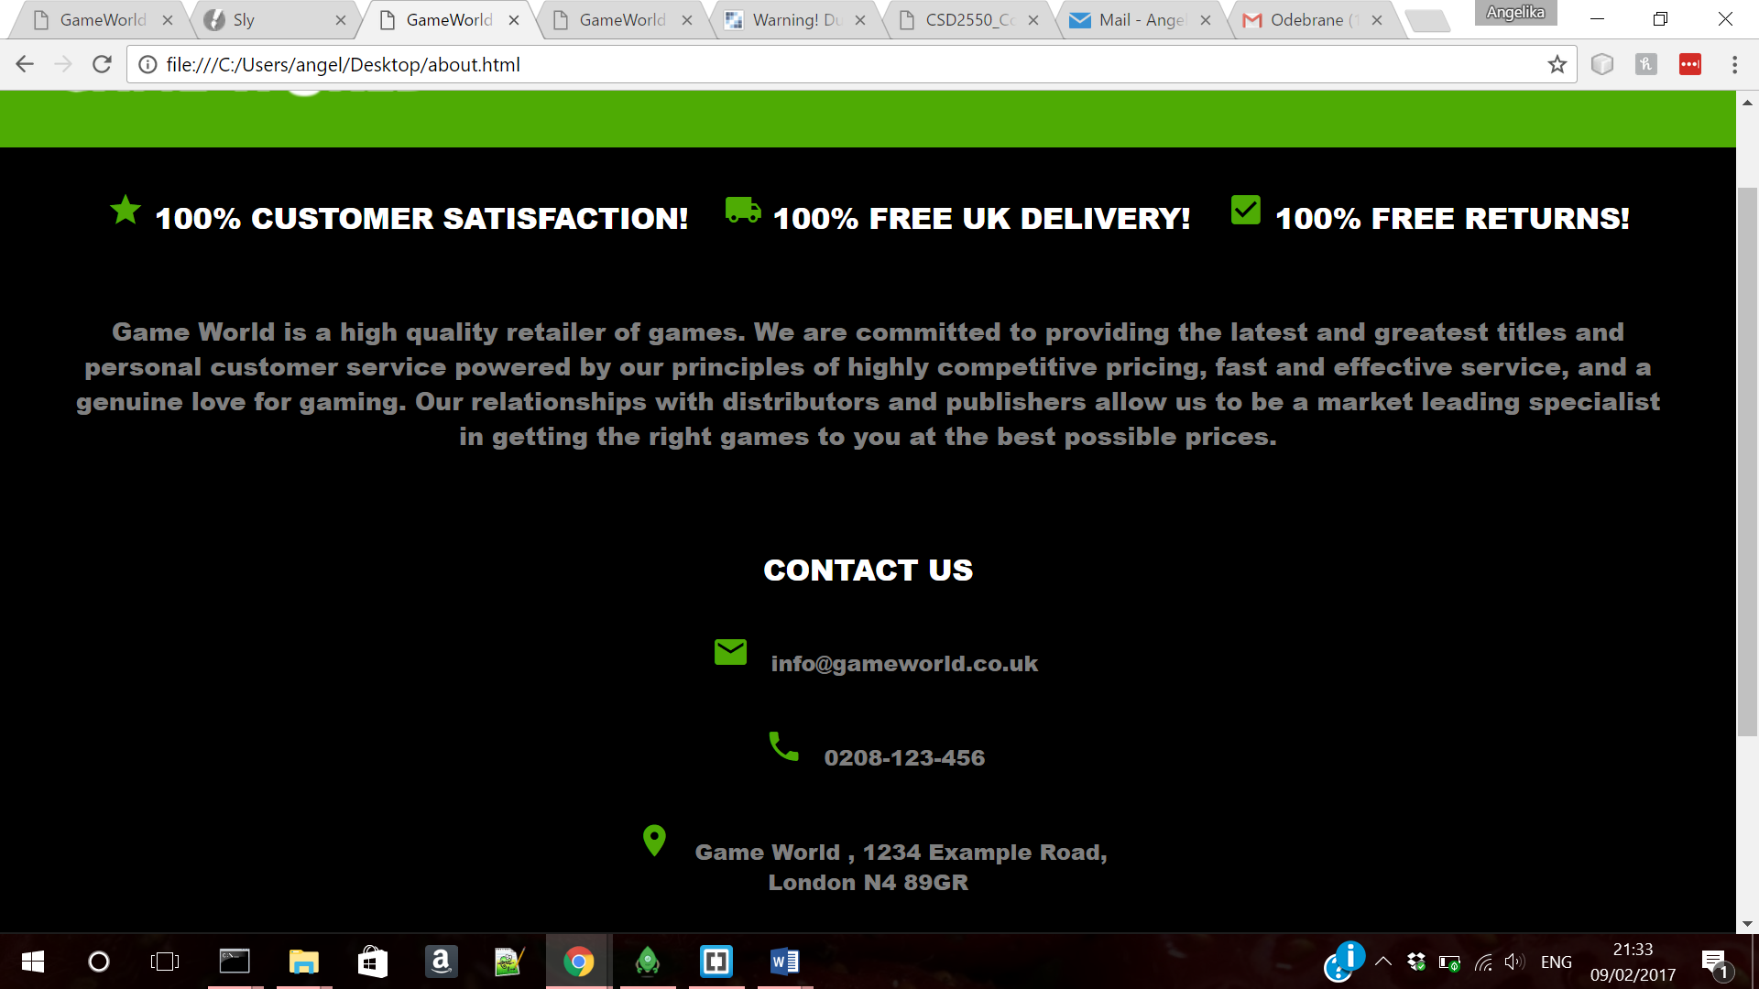

Login page contains a HTML form which allows customer to sign in to their account.

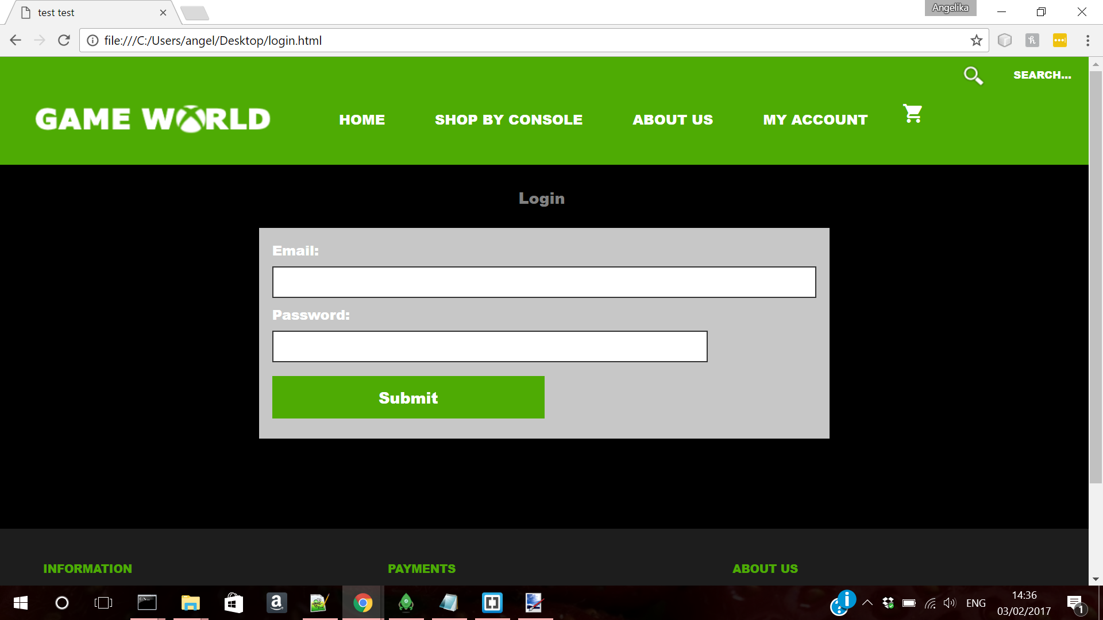

Registration page includes HTML form which allows users to create new accounts.

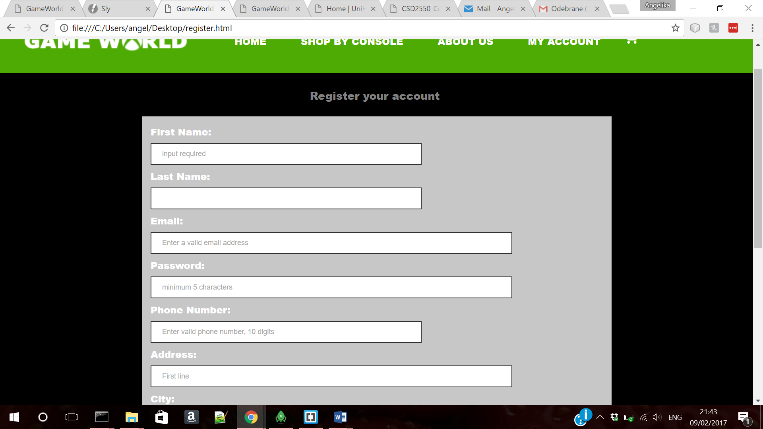

My Info page, once it is fully implemented, will allow customer to view their orders, amend their personal details as well as it will give customer product recommendation based on their previous choices and products they have viewed.

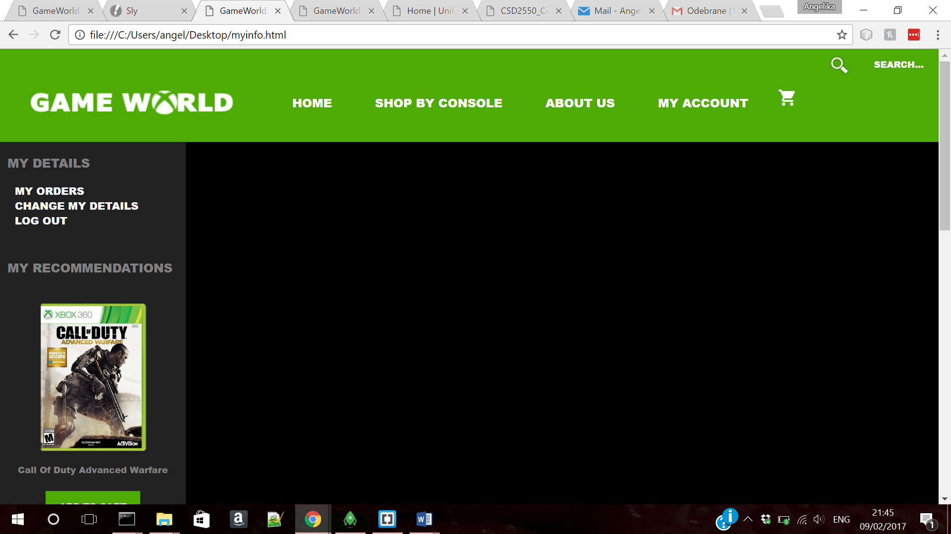

Cart page allows customer to view the items they have added to their basket, see the total price and make their purchase.

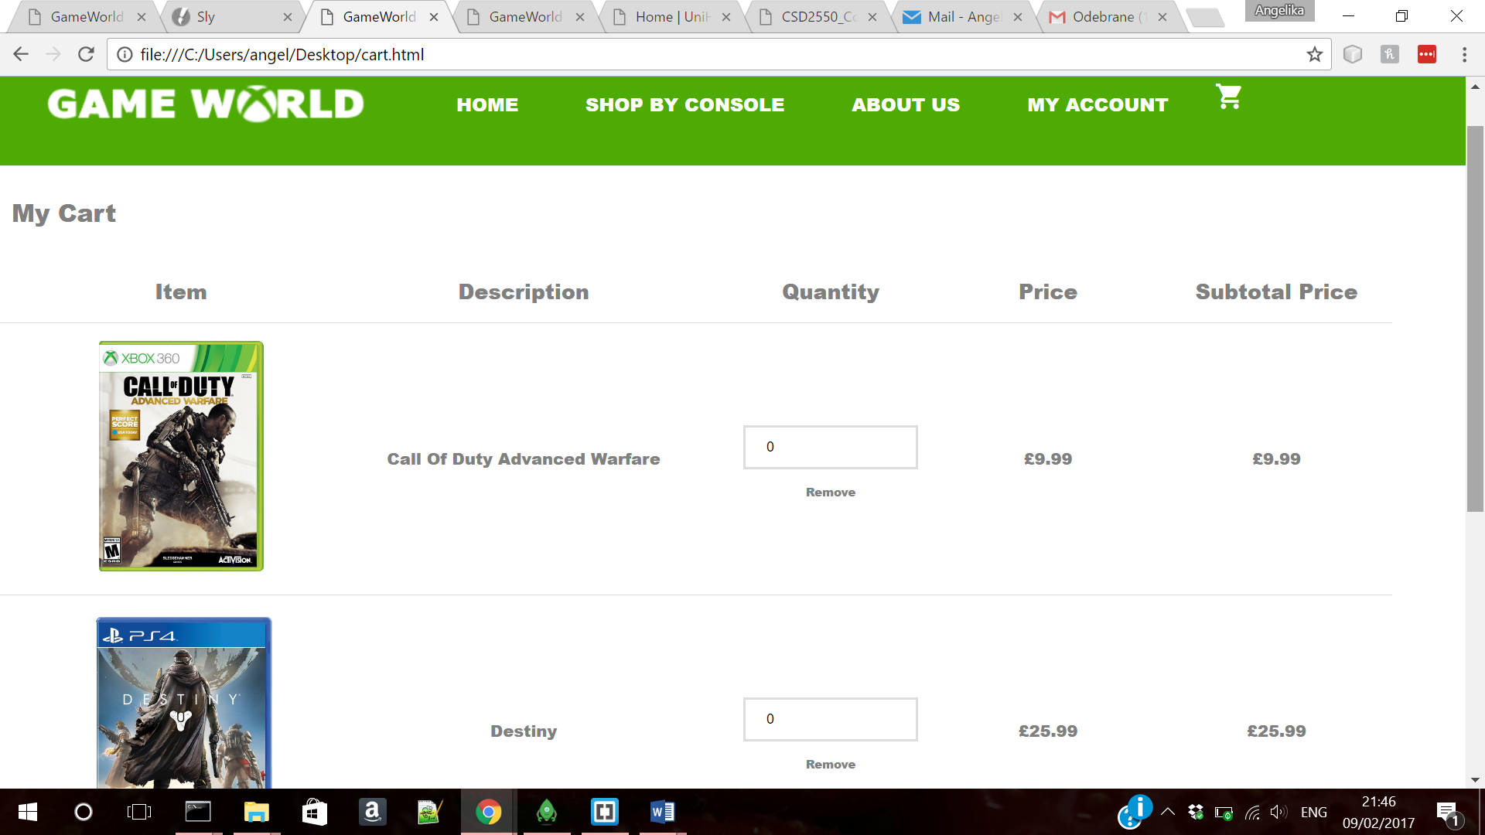

**CONTENT MANAGEMENT SYSTEM:**

Front end of the content management system was also developed. Firstly staff members would have to log in using their StaffID to access other pages.

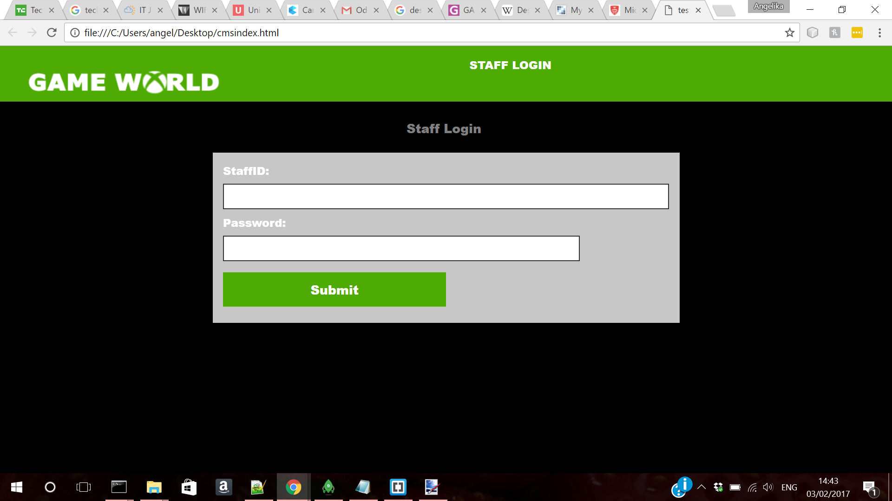Content management would allow staff member to add new products using HTML form

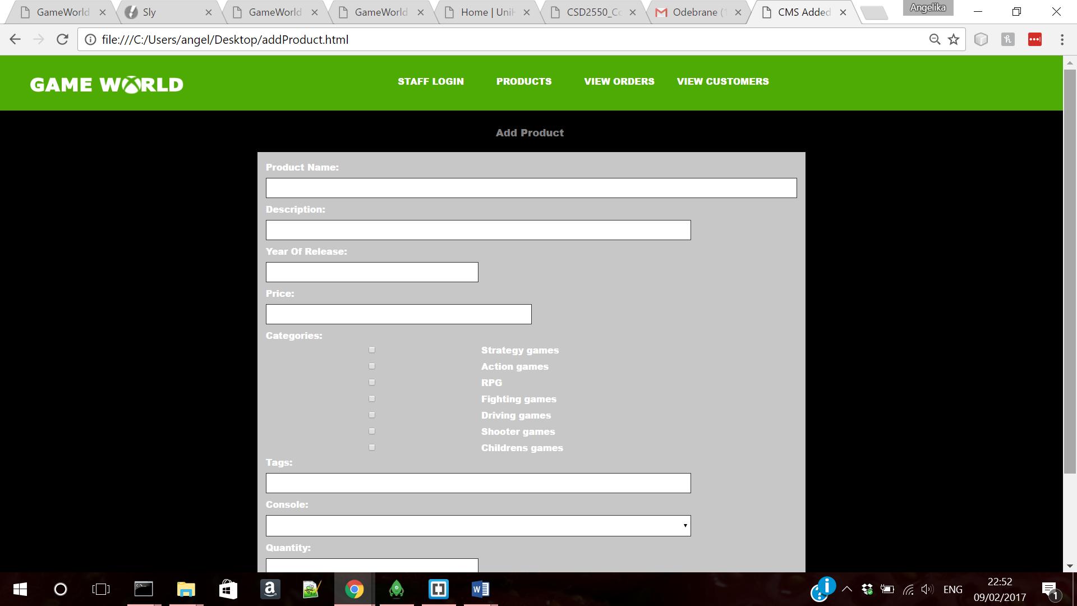

Staff members can also delete and edit products using content management system and search bar to find the product they require.

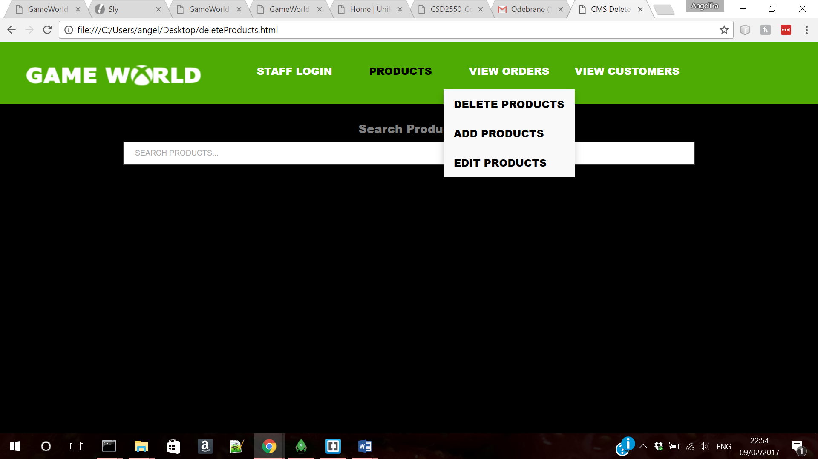

Another function of CMS is viewing orders and customers database, using similar search function:



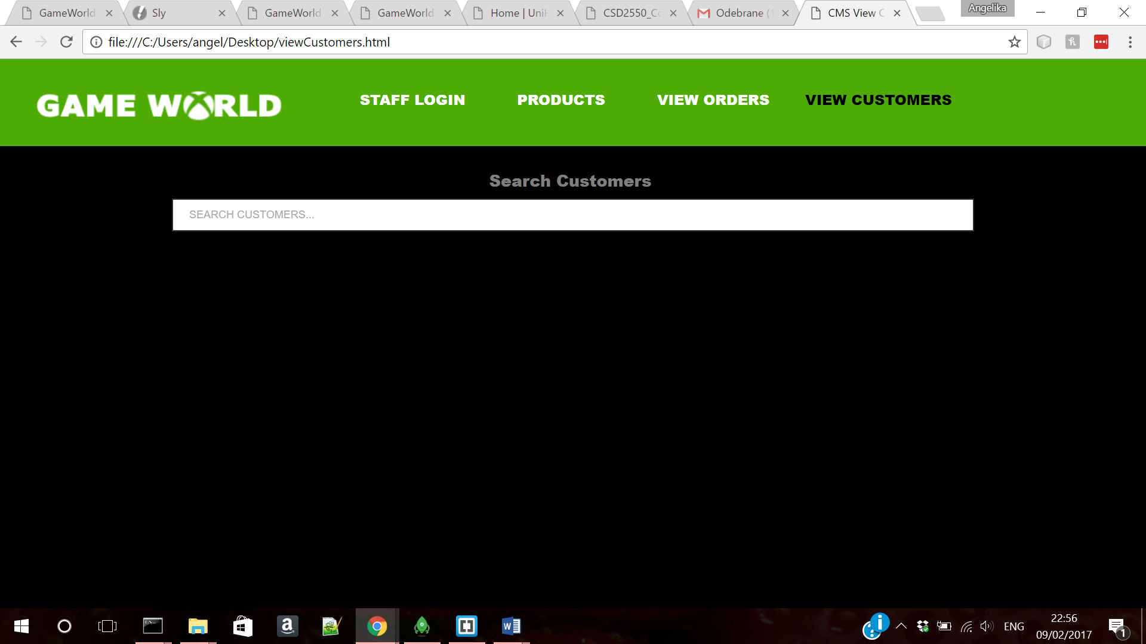

**DATABASE DESIGN:**

Database design was implemented in MongoDB, we have decided to create 5 collections:

* Products
* Orders
* Customers
* Carts
* Staff

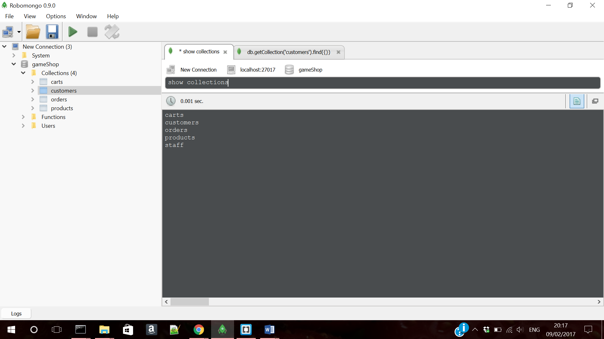

Products collection – example document:

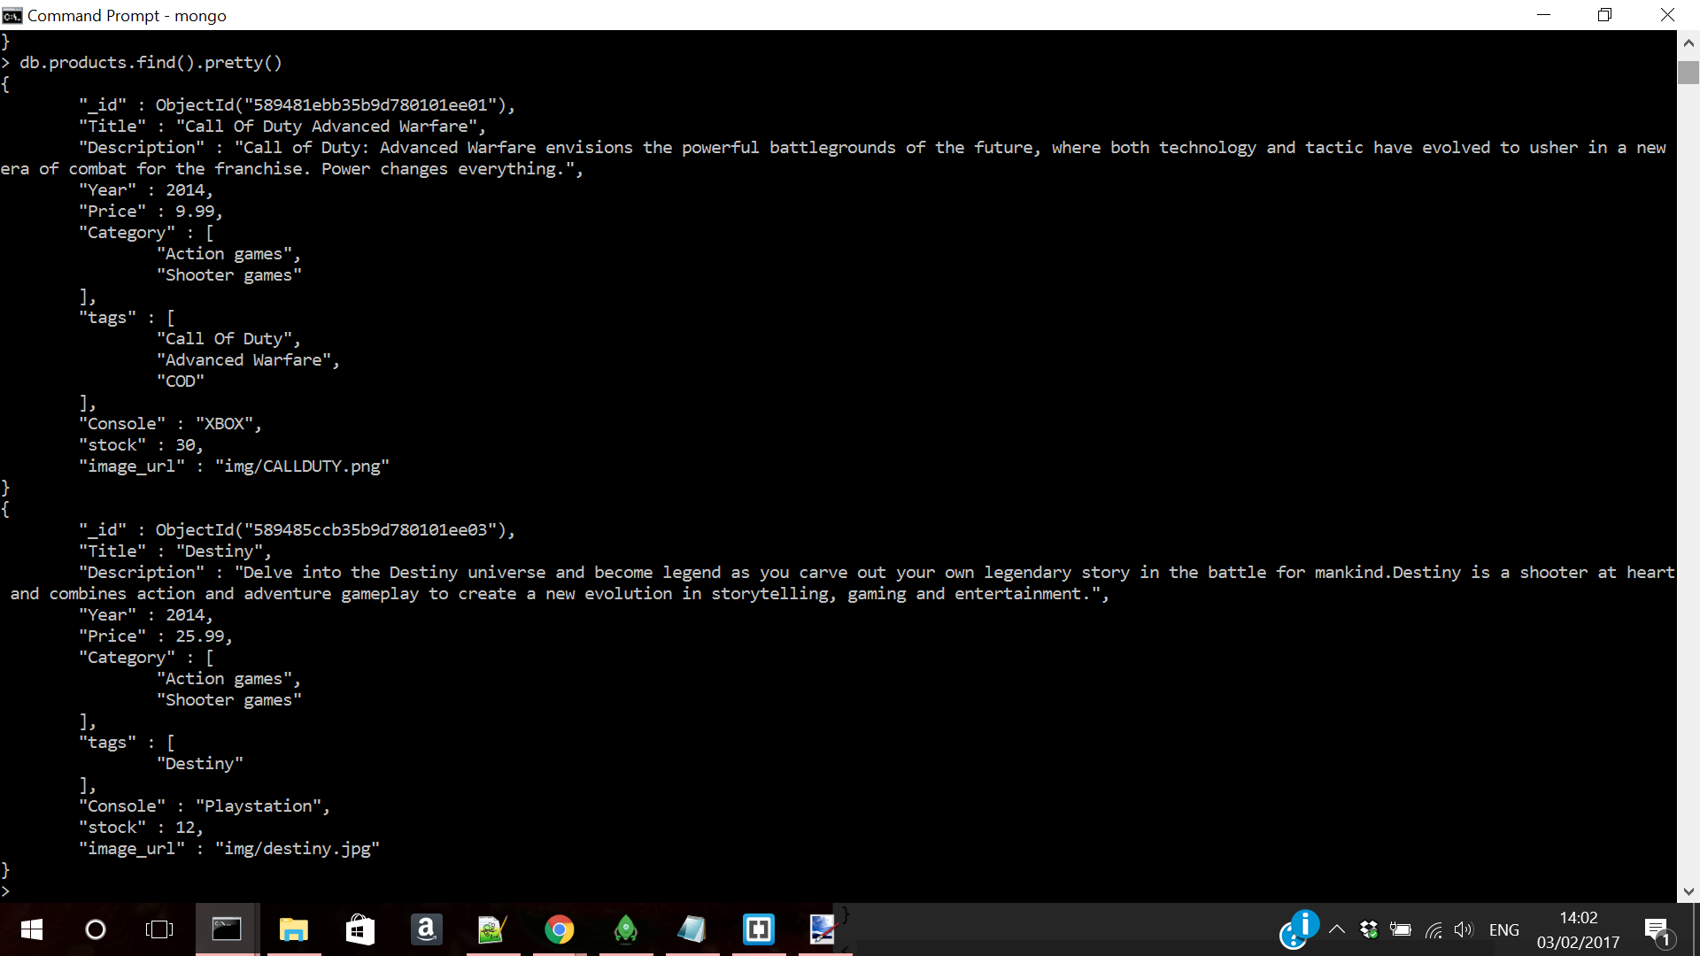

Product database collection – this collection will store all the products we have available; the games available in the different platforms, genre of the game, price, stock level, image link for the website, as well as tags which will help to implement the search feature.

Customers collection example document:

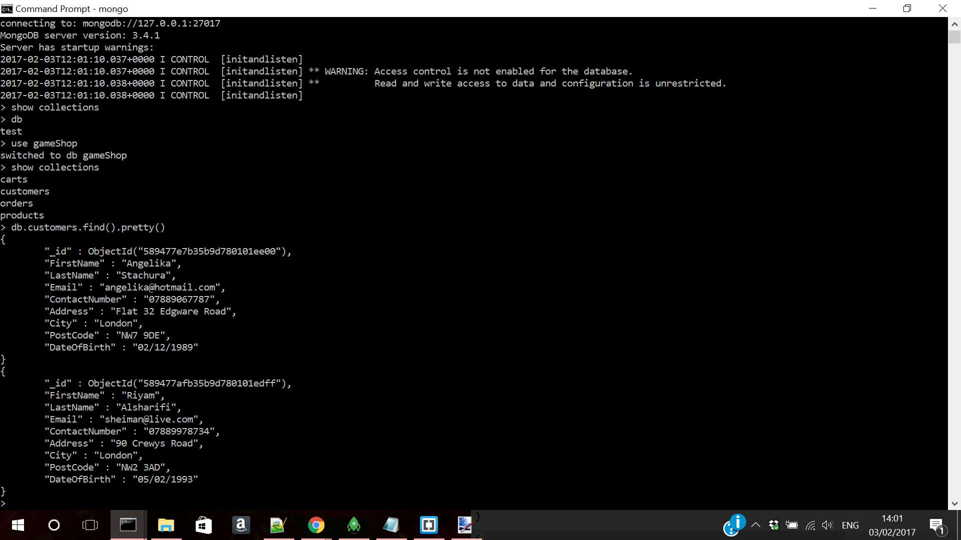

Customers collection – includes all customer’s information, their address, first and last name, email, date of birth, contact number.

Orders collection example document:

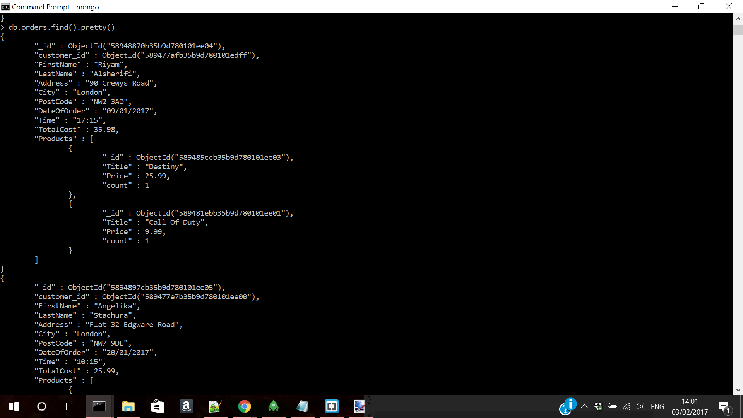

Orders collection – allows us to save customers’ orders; includes unique customer ID which would allow to create a relationship between orders collection and customers collection, as well as time of the order, customers personal details and products they have order along with their unique ID.

Carts collection example document:

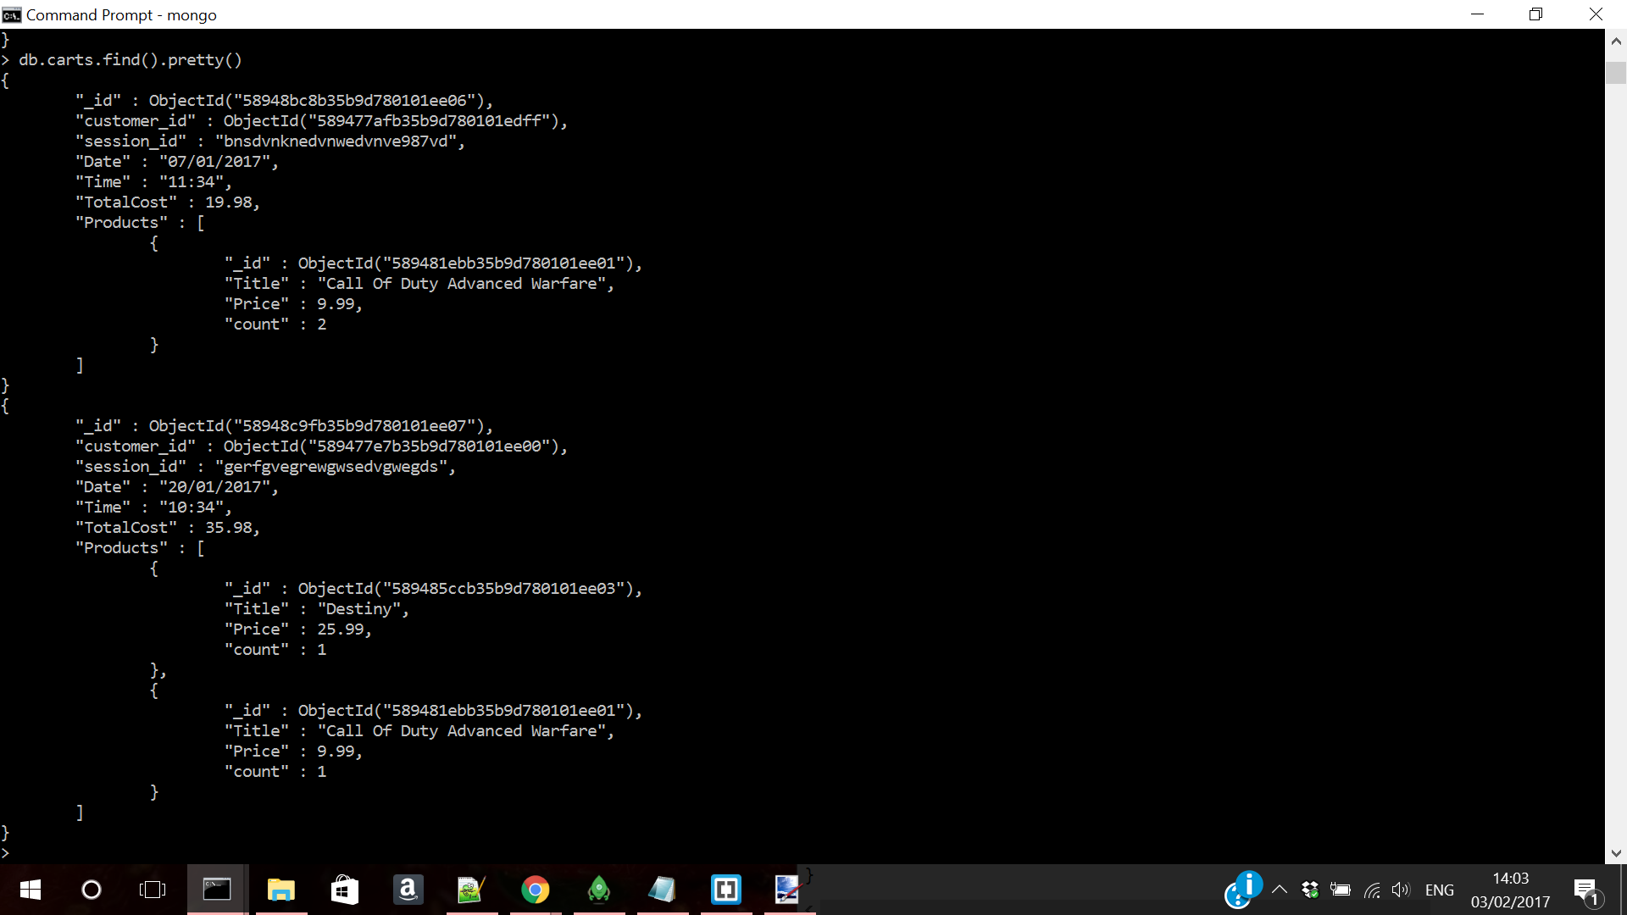

Carts collection document contains customer details like their unique ID, the time the cart was created, as well as the products information like their ID, quantity, price and total price of the basket.

Staff collection example document:

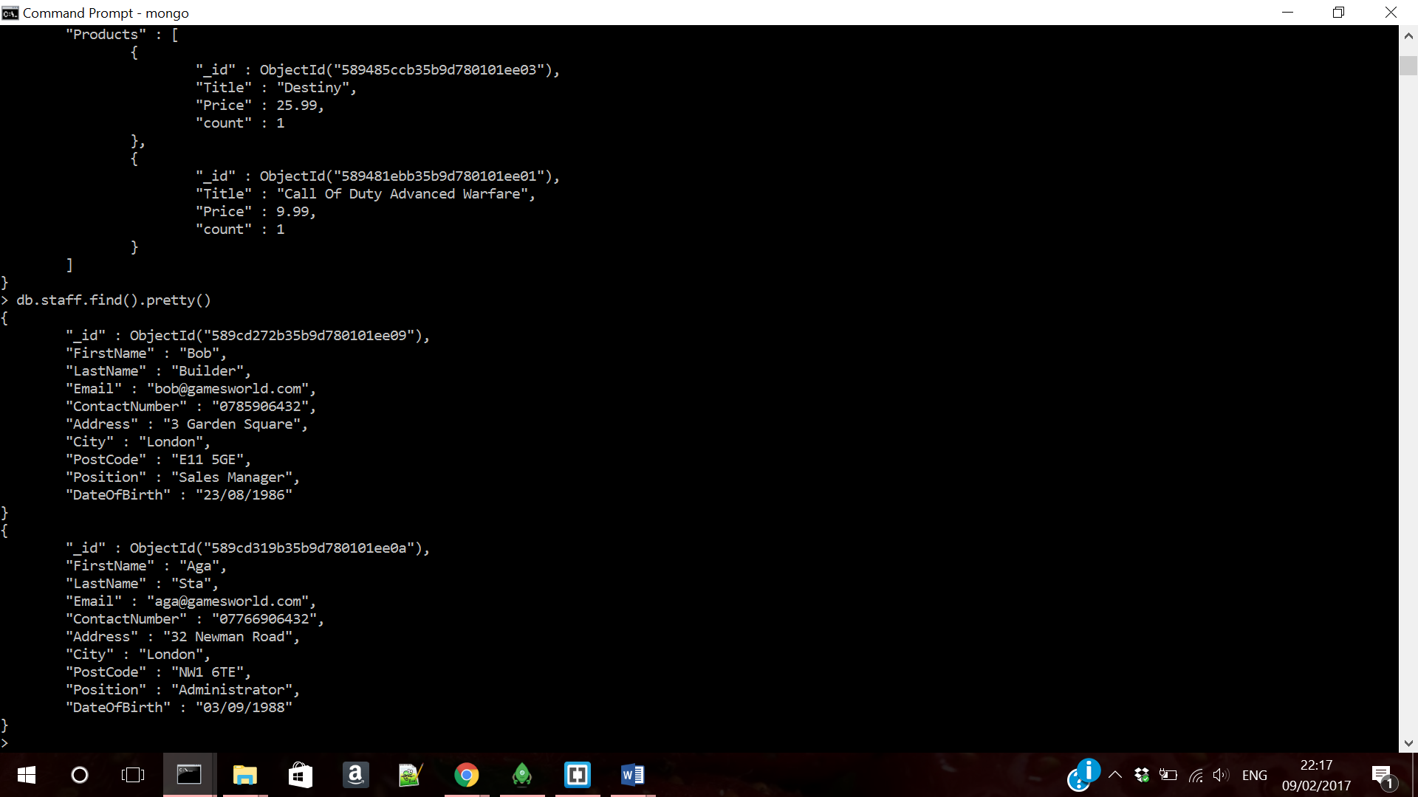

Staff collection document includes their personal details like first and last name, email, contact number, address, date of birth and position.

**TEAM CONTRIBUTIONS:**

|  |  |  |
| --- | --- | --- |
| **Name** | **Contribution** | **Tasks completed** |
| Angelika | 10 | * Front end web * Front end of CMS * Improvement on report and database design |
| Riyam | 8 | * MongoDB database design and example documents |
| Ammar | 7 | * Wrote the report |